* REVISITING AI PROJECT CYCLE

PROBLEM

SCOPING

DATA

EXPLORATION

MODELLING

DATA

AQUISITION

EVALUATION

| **Problem Scoping** | Understanding the problem |
| --- | --- |
| **Data Acquisition** | Collecting accurate and reliable data |
| **Data Exploration** | Arranging the data uniformly |
| **Modelling** | Creating Models from the data |
| **Evaluation** | Evaluating the project |

Example – You want to buy a new car.

1. **Checking** the factors like budget, number of seats required, types (sedan or SUV), colour etc Which will help us decide the next steps and understanding the Project.
2. **Acquiring** data from different sources like internet, from friends, from car dealerships etc for costs, more choices and offers.

 

1. Making a list of the gathered data and choosing the required specifications according to the budget.



1. Creating or **Modelling** a requirements on the basis of the data collected as what colour of car you want and what type you want with all pictures presented in it.
2. Showing it to Parents or cousins to Let them check it or **evaluate** it.

* INTRODUCTION TO CHATBOTS

Chatbots are software applications that use artificial intelligence & natural language processing to understand what a human wants, and guides them to their desired outcome with as little work for the end user as possible. Like a virtual assistant for your customer experience touchpoints.

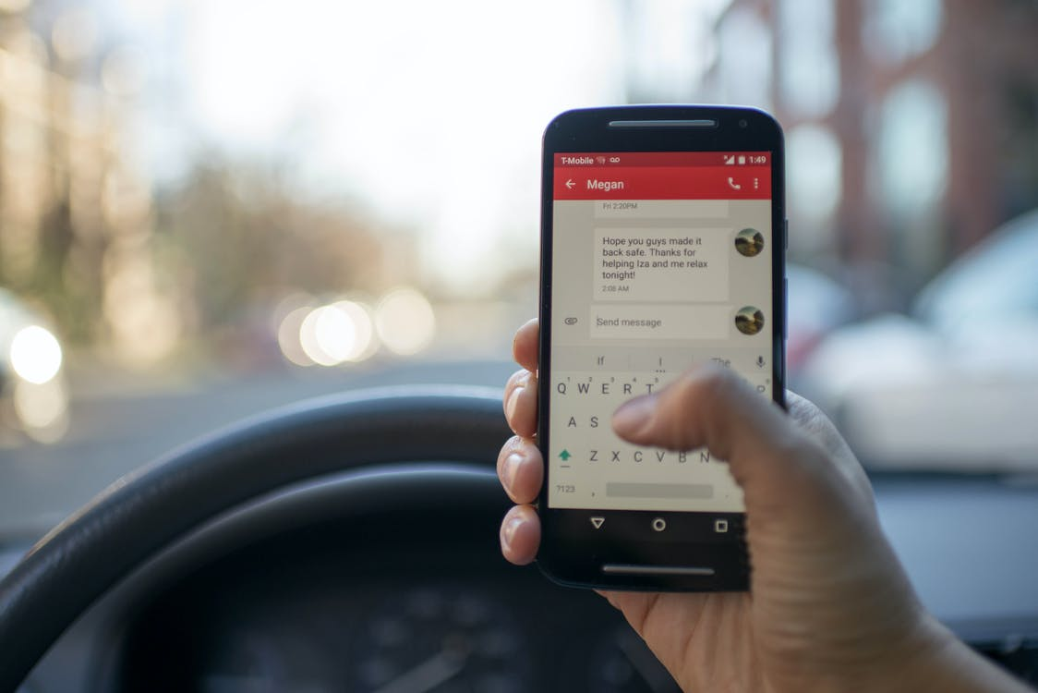

A well designed & built chatbot will:

1. Use existing conversation data (if available) to understand the type of questions people ask.
2. Analyze correct answers to those questions through a ‘training’ period.
3. Use machine learning & NLP to learn context, and continually get better at answering those questions in the future.

One of the most interesting parts of the chatbot software space is the variety of ways you can build a chatbot. The underlying technology can vary quite a bit, but it really all comes down to what your goals are. At the highest level, there are three types of chatbots most consumers see today:

Artificial Intelligence

Chatbots

Live

Chatbots

Rules-Based

Chatbots

These chatbots follow pre-designed rules, often built using a graphical user interface where a bot builder will design paths using a decision tree.

AI chatbots will automatically learn after an initial training period by a bot developer

These bots are primarily used by Sales & Sales Development teams. They can also be used by Customer Support organizations, as live chat is a more simplistic chat option to answer questions in real-time.

* BENEFITS

Increase their website conversion rate – Marketers put a lot of work in to drive traffic to their website, to only have that traffic convert anywhere between 0.25%-1.0%.

Generate more qualified leads –

It would be nice if we could talk to every lead and ensure they’re a good fit before we schedule a meeting. In reality, that’s impossible for most organizations to do at scale.

Combat Customer Churn –

Bots are a perfect answer to high-volume support inquiries, especially where customers become frustrated with standard knowledge bases that are hard to shift through.

* EXAMPLES

1. [Slush – Answer FAQs in real time](https://www.revechat.com/blog/chatbot-examples/#step1)

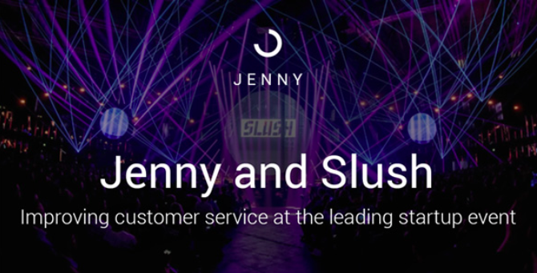

1. [Vainu – Enrich customer conversations without form fill ups](https://www.revechat.com/blog/chatbot-examples/#step2)

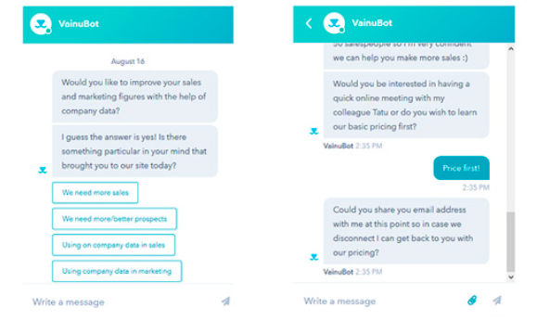

1. [Dominos – Deliver a smooth customer experience via Facebook messenger](https://www.revechat.com/blog/chatbot-examples/#step3)

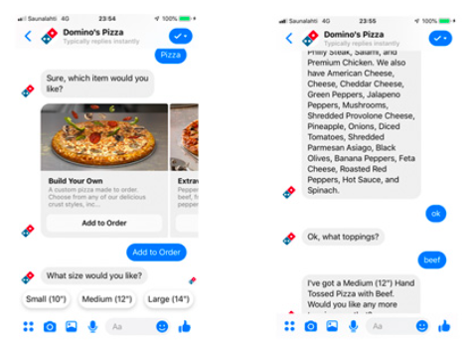

* HUMAN V/S COMPUTER LANGUAGE

We all know that the computer understands instruction given by us, what to do. It would be nice if we could tell the computer what we want as in science fiction movies, even if we could do also, our human language is full of ambiguity and imprecision.



Example: suppose if I say, I saw a bird on the tree branch with telescope yesterday at 6 pm, Then how can a computer understand this

The computer does not know what is a bird? who are you? what is 6 pm? , what is a tree branch? what is yesterday? where did you saw a bird? to express this simple sentence to a computer we have to actually create each word(bird, tree, telescope) into programming instruction, however our human language simple in a sense with help of common knowledge we share.

* HUMAN TO COMPUTER COMMUNICATION

Being human you have a lot of experience and common knowledge that computers will not so, in order to communicate with the computer, you have to describe each element of the whole picture

The truth is human language communication contains common knowledge. which they share with each other but when it comes to the computer. the computer does not have any common knowledge stored with it so that, it could directly understand us.

So the barrier between us and a programming language is the common knowledge and experience that we have.

On the other hand, the computer understands the language of numbers. Everything that is sent to the machine has to be converted to numbers. And while typing, if a single mistake is made, the computer throws an error and does not process that part. The communications made by the machines are very basic and simple.

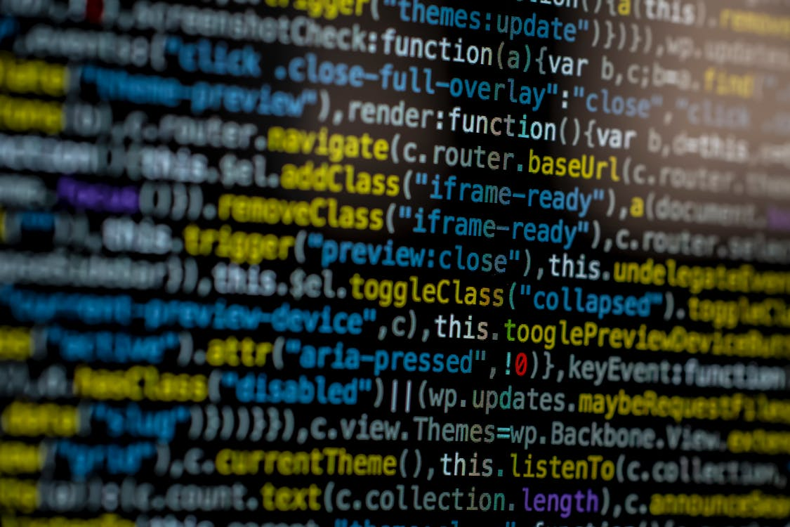 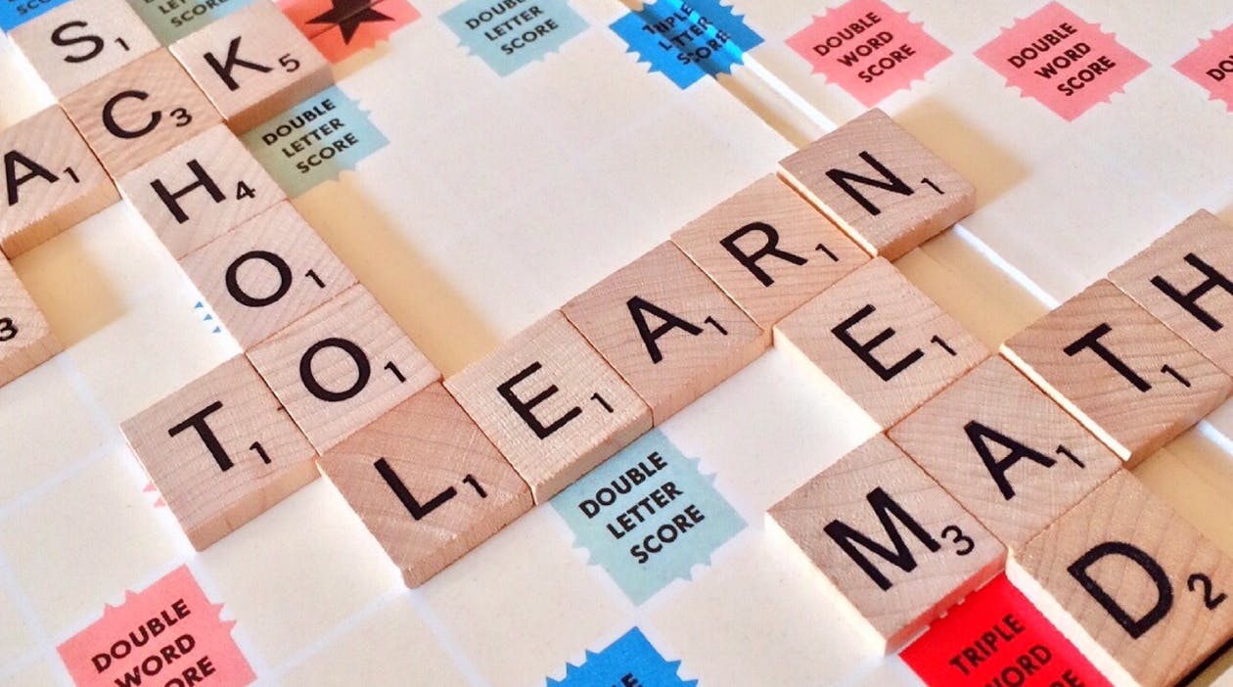

* DATA PROCESSING

Data processing, is the manipulation of data by a computer. It includes the conversion of raw data to machine-readable form, flow of data through the CPU and memory to output devices, and formatting or transformation of output. Any use of computers to perform defined operations on data can be included under data processing.

For Example – A Spanish person says something to you, you will convert it into the language you understand.

* BAG OF WORDS

Bag of Words is a Natural Language Processing model which helps in extracting features out of the text which can be helpful in machine learning algorithms. In bag of words, we get the occurrences of each word and construct the vocabulary for the corpus.

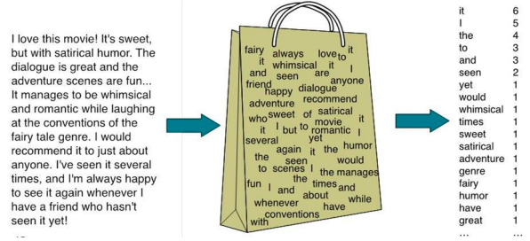

This image gives us a brief overview about how bag of words works. Let us assume that the text on the left in this image is the normalised corpus which we have got after going through all the steps of text processing. Now, as we put this text into the bag of words algorithm, the algorithm returns to us the unique words out of the corpus and their occurrences in it. As you can see at the right, it shows us a list of words appearing in the corpus and the numbers corresponding to it shows how many times the word has occurred in the text body. Thus, we can say that the bag of words gives us two things:

1. A vocabulary of words for the corpus
2. 2. The frequency of these words (number of times it has occurred in the whole corpus)

* TF-IDF (TERM FREQUENCY — INVERSE DOCUMENT FREQUENCY)

TF-IDF stands for “Term Frequency — Inverse Document Frequency”. This is a technique to quantify a word in documents, we generally compute a weight to each word which signifies the importance of the word in the document and corpus. This method is a widely used technique in Information Retrieval and Text Mining.

If i give you a sentence for example “This building is so tall”. Its easy for us to understand the sentence as we know the semantics of the words and the sentence. But how will the computer understand this sentence? The computer can understand any data only in the form of numerical value. So, for this reason we vectorize all of the text so that the computer can understand the text better.

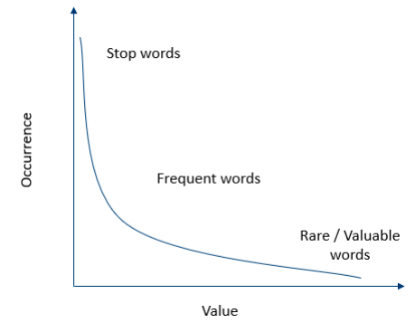

By vectorizing the documents we can further perform multiple tasks such as finding the relevant documents, ranking, clustering and so on. This is the same thing that happens when you perform a google search. The web pages are called documents and the search text with which you search is called a query. google maintains a fixed representation for all of the documents. When you search with a query, google will find the relevance of the query with all of the documents, ranks them in the order of relevance and shows you the top k documents, all of this process is done using the vectorized form of query and documents. Although Googles algorithms are highly sophisticated and optimized, this is their underlying structure.

TF-IDF = Term Frequency (TF) * Inverse Document Frequency (IDF)

Terminology

t — term (word)

d — document (set of words)

N — count of corpus (corpus — the total document set)

* NATURAL LANGUAGE TOOLKIT (NLTK)

NLTK, or Natural Language Toolkit, is a Python package that you can use for NLP.

A lot of the data that you could be analyzing is unstructured data and contains human-readable text. Before you can analyze that data programmatically, you first need to preprocess it.

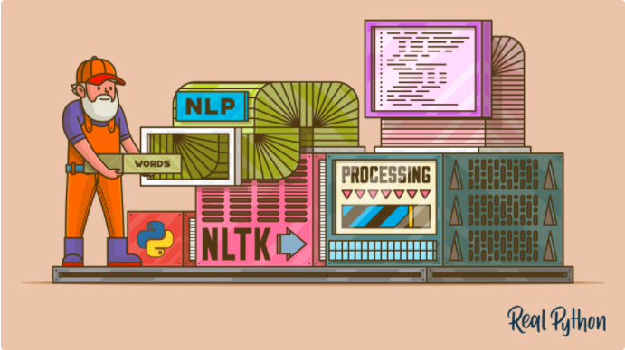

You’ll take your first look at the kinds of text preprocessing tasks you can do with NLTK so that you’ll be ready to apply them in future projects. You’ll also see how to do some basic text analysis and create visualizations.